HAWKER SCHOOL P&C
MUSIC & DRAMA SCHEME 2019

The Scheme
The Hawker School P&C Music and Drama Scheme provides affordable school-based music and drama tuition for students attending Hawker School during the term. Individual music lessons and group guitar lessons are held during school times. Drama and choir are held before or after school. The Scheme is run by volunteer parents who form a sub-committee of the Hawker School P&C.
The Scheme operates to enrich children’s lives through the arts by providing tuition in piano, violin, guitar, drama and choir.
The Scheme works closely with the school to ensure lessons do not clash with French or Music, which are lessons difficult to make up, as the classroom teacher does not teach these lessons. There are generally eight lessons per term to allow for make-up lessons missed from illness or school events. Parents are billed directly by the tutor per term, with fees due prior to the commencement of lessons.
We encourage all parents to come along to at least one lesson to meet your child’s tutor.
Enrolment
Enrolment is done via the MusicBiz online registration. Any questions about enrolment can be forwarded to the Music & Drama Scheme Registrar.
Priority is given to continuing students. New students to the program are offered a place when spots become available. Waiting lists are well maintained.
Enrolment Fee
An enrolment fee is charged each year of $30 per student to cover the cost of our MusicBiz software to manage the program, the end of year concert, and piano tuning. This fee is payable through Flexischools upon enrolment.
Performance
All students have the opportunity to perform at the end of year music concert, usually held on a Thursday evening at the end of November. There may also be a small mid-year concert.
Music Terms
Term 1 – Week 3 - 10
Term 2, 3 & 4 – Week 1 - 9

Music and Drama Sub Committee
Music and Drama Scheme Registrar:
Danielle Gilchrist
E: HawkerMusicScheme@gmail.com

Music and Drama Scheme Co-ordinator:
Radha Hanigan
E: radha.hanigan@gmail.com

Piano Co-ordinator:
Scott Wilkinson
E: scottnleanne@grapevine.com.au

Drama Co-ordinator:
Lorna Indrele
E: lorna.indrele@iinet.net.au

PIANO AND VIOLIN
Cost: $38 per 30 minute lesson, 9 week Term ($342 per term)
Please contact the Music & Drama Scheme Registrar if you would like to be added to the waiting list.
BETHANY ROBERTS – PIANO
Bethany began learning piano at age 10 and started progressing through practical and theoretical exams while in her early teens. In 2010 Bethany began teaching piano privately and in schools across Canberra.
"A good piano teacher can make a world of difference in your child's musical development. My first piano teacher was fun and kind and I hold my love of music as credit to her.
This inspires me to instil in your child a love of music, while still giving them a strong technical foundation. I encourage my students to play with expression and emotion and do my best to ensure they are playing music they love.
I hope my students continue to learn and play piano long after they have finished their musical studies."
GEOFFREY WARREN – PIANO
Geoffrey commenced piano lessons at the age of five. In year 12, Geoffrey was offered a Scholarship to the Sydney Conservatoire and completed his Bachelor of Music (Hons) at the age of 23.
From then he began teaching, commencing with a practice in Bingara NSW. After 8 years in various Australian country towns, Geoffrey travelled to England and spent the next few years at Norwich University, earning a Post Graduate degree in Impressionism in 19th Century France.
Returning to Australia, Geoffrey and his wife Kathryn, also a Post Graduate pianist and Theorist have a successful teaching studio in Hawker – which they have run for over 32 years.
“I love teaching at Hawker Primary as the children are so cheerful and eager to learn. It has been my privilege to educate young minds to the gift that is music.”
ARIANNE TAN – PIANO & VIOLIN
Arianne began teaching at Hawker in 2019, offering lessons in both violin and piano.
As a passionate music educator, Arianne works full-time conducting music bands, coordinates instrumental programs in the ACT/NSW and offers private instrumental lessons in collaboration with schools, both during and after school hours.
She prepares students for ‘The Australian Music Examination Board (AMEB), the ‘Associated Board of the Royal Schools of Music’ (ABRSM) syllabuses, youth orchestras, ensembles, in both small groups and one-to-one settings. To date, Arianne has collaborated with a total of sixteen schools located in the national capital.
Arianne’s teaching philosophy is closely related to the philosophy of those who were teaching “the Sound before the Symbol” such as Orff, Suzuki, Kodaly and others, but taking their ideas to suit each of her students.
GUITAR
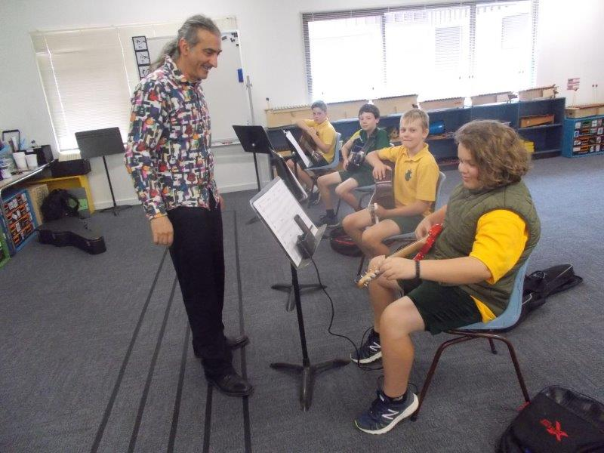 | Cost: $38 per 30 minute individual lesson, 8 week Term ($342 per term)  Cost: $21 per 30 minute group lesson, 8 week Term ($168 per term)  Please contact the Music & Drama Scheme Registrar if you would like to be added to the waiting list.
MARCIANO TELESE – GROUP LESSONS ONLY
Marciano has been teaching guitar at Hawker since 2013 and offers group guitar lessons. “From a very young age I was fascinated with music. A magical world that produced such amazement and joy in me that I often would gaze and be transported as musicians performed in front of me. I couldn't comprehend the music at the time but eventually with many years of practice and study I began to share in the celebration of performing and creating music.
My performance background was mainly pub rock music during the 1980's.
Through the next two decades I studied music composition and started a family. My greatest composition to date!
I have three lovely children along with a very supportive partner and super-mum to our children. These days my performing is studio based where I focus music production for clients.”
MOJO GUITAR – INDIVIDUAL AND GROUP LESSONS
Mojo Guitar is focused on providing a fun, motivating, nurturing and educational musical experience to students.
We have Hayley and Ken from Mojo teaching at Hawker, both passionate and experienced guitar teachers.
www.mojoguitarteachers.com

DRAMA
Drama Students at Hawker Primary School will be challenged to express themselves in a safe, fun and supportive environment. Workshops will explore various Drama games and exercises, as well as teach theatrical concepts and acting skills; such as improvisation, scene construction, play-building, character work, vocal expression, role-play, rehearsal techniques and basic stage craft. Drama promotes empathy and understanding, strengthens social connections, encourages collaboration, enables group discussion, develops problem solving skills, builds confidence, and exercises the imagination!
Cost per student: $130 per term (8 classes per term).
Early bird rate: $250 per semester (paid by end of week 1 of Semester 1 & 2).
Drama is run in Unit 6, (the Music Room) on Tuesdays as follows:
- Juniors (years 1-3): 8am to 9am
- Seniors (years 4-6): 3pm to 4pm
Performance Outcome: There will performances for each Drama group (5-10 min) during the year and also part of the end of year Hawker Music and Drama Scheme Concert.
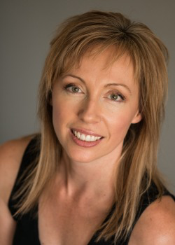
RUTH PIELOOR
Ruth Pieloor is a trained Actor (BA Performance UWS Theatre Nepean), holds a Bachelor Teaching (UWS 2002 Drama Secondary/Primary) and has been teaching Drama in various schools in Sydney and throughout Canberra since. Ruth tutors regularly with Canberra Youth Theatre and ImproACT and is passionate about Theatre and nurturing creative opportunities for children and young people. Ruth is an Actor, Puppeteer, Improviser, Writer and Director and a member of Actors Equity MEAA since 1992.
https://www.ruthpieloor.com/tutor

CHOIR – The Hawker Harmonists
Who: Years 3-6
When: 8.00 -8.45am every Thursday during the school term. Extra rehearsals may be called before a performance.
Cost: $90 per student per term, depending on enrolments
Free trial: students are welcome to try one lesson for free
The Hawker Singers are looking for new members and would be delighted to welcome children of all singing abilities.
VERONICA THWAITES-BROWN GradDipEd, BAHons, LMusA, AMusA
M: 0414 978852, E: vcthwaites.gmail.com
Veronica is a classically trained singer, pianist and music educator, and a graduate of Sydney University and the University of Canberra. She currently teaches at Canberra Girls' Grammar as Assistant Dean in Music, and has previously taught at Hawker College, Lyneham High and Telopea Park School. She has conducted bands and choirs in Canberra for over 13 years.
Veronica is also a seasoned performer as a soloist in numerous Canberra concerts and theatrical productions, including for CCS in Handel’s Messiah and Vivaldi’s Gloria, for Coro Chamber Choir, in the Canberra International Music Festival, and for the Llewellyn Choir in Saint-Saens’ L’Oratorio de Noel. Theatrical roles include the ‘Baker’s Wife’ in Into the Woods, ‘La Speranza’ in the ANU production of L’Orfeo, and ‘Maria’ in The Sound of Music at The Q theatre.
Veronica believes that singing and music making is the right of every human being and creates an environment where kids feel welcomed and empowered through fun songs, vocal exercises, musicianship and friendship.

Terms and conditions

The Hawker School P&C Music and Drama Scheme is a subcommittee of the Hawker School P&C Association.
The scheme agrees to provide tuition in music and drama to students of the Hawker School as outlined in the below conditions and the parents/carers agree that the tuition is accepted under these conditions.
Lessons – Piano, Violin and Guitar
1. Each student will receive eight (8) lessons of thirty (30) minutes duration each school term. A theory/musicianship lesson will be given when the student forgets music/instrument.
2. Lessons will be given between 9am and 3pm. The organisation of the timetable will consider the demands of the school class timetable where possible and will allow for adequate spacing between music lessons.
3. In the event of the Association not being able to provide lessons for any reason, it cannot be held responsible.
Lessons – Choir
4. Payment is a flat fee per term and pro rata rate will not be available.
Lessons – Drama
5. Payment is a flat fee per term and pro rata rate will not be available.
Group Lessons
6. If a student’s behaviour in a group situation is unacceptable the tutor may have the student sit out of the activity or return to class.
Fees
7. The cost of the lessons is the responsibility of the parent and will be paid on a term basis. Parents will be invoiced directly by the tutor. Payment is required 2 weeks after accounts are sent out.
8. The cost of instruments, books and any script required by the tutor from time to time will be borne by the parent.
Absences
9. When students are absent it is the parents’ responsibility to notify the music tutor directly.

10. Individual Lesson Absence:
- If absence is advised by 9am of day of the lesson, every effort will be made to ‘make up’ these lessons. In the case of no ‘make up’ being provided you will be refunded the appropriate fee or given a credit to the next semester account.
- If the absence is not advised to the tutor prior to the lesson, no makeup or refund will be provided.
- When lessons are to be missed due to whole of school activities or Public Holidays the Coordinators will advise the music tutors. If possible, lessons will be ‘made up’. If individual classes have excursions or activities which will prevent attendance at a music lesson, it is the responsibility of the parent to notify the tutor.
11. Group Lesson:
- When group lessons are missed, these lessons will not be ‘made up’ nor money refunded, unless prior arrangements have been made and agreed by the tutor.
Termination
12. A parent may terminate lessons at any time by providing written notice four (4) weeks in advance to the relevant co-ordinator of the Music and Drama Scheme sub-committee of the Hawker School P&C Association.
13. The Hawker School P&C Association may terminate lessons to a student on the recommendation of the Principal, following discussions with the music tutor and the parent; without penalty to the parent.
Administration
14. The music tutor’s appointment is by the Hawker School P&C Association only. A music tutor is not an employee of the Department of Education and is not responsible to it. All tutors undergo regular police checks as required by the Department; they also carry current Working with Vulnerable People cards and their own insurance.
15. The Hawker Music Scheme coordinators are available to liaise between parents and tutors. Parents are also encouraged to contact music tutors directly to discuss their child’s progress.
16. The Principal of the Hawker School, acting in his/her capacity as an ex-officio member of the Hawker School P&C Association, is responsible for the conduct and organisation of the lessons; and will act as mediator between any parent and tutor if necessary.

